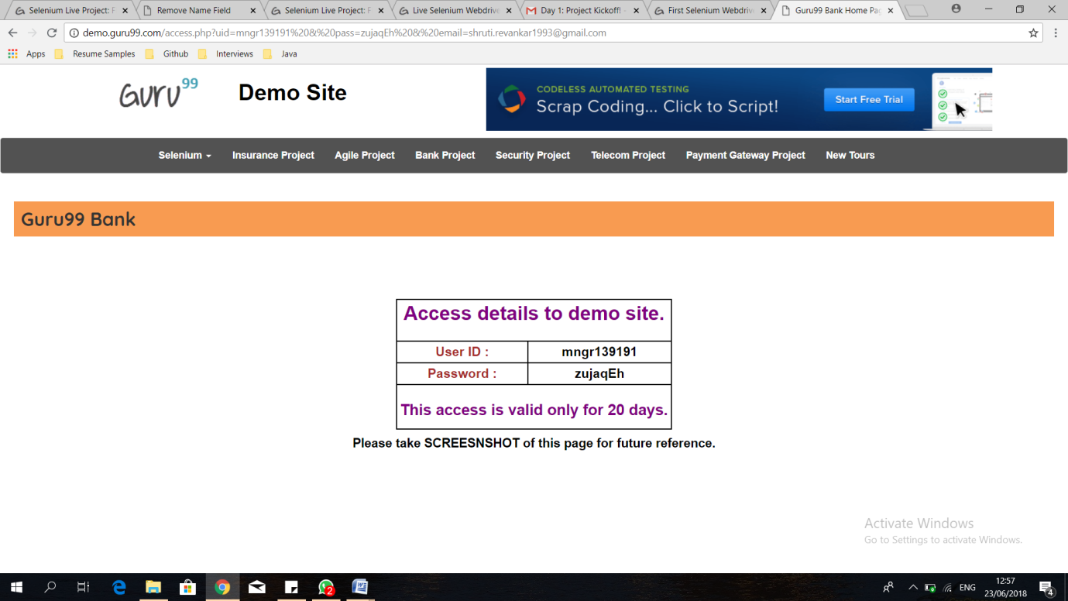

**import** org.openqa.selenium.Alert;

**import** org.openqa.selenium.By;

**import** org.openqa.selenium.WebDriver;

**import** org.openqa.selenium.chrome.ChromeDriver;

**public** **class** Login {

**public** **static** **void** main(String[] args) {

System.*setProperty*("webdriver.chrome.driver", "C:/Selenium Prerequisists/chromedriver.exe");

WebDriver driver = **new** ChromeDriver();

String baseURL = "http://www.demo.guru99.com/V4/";

driver.get(baseURL);

String expectedTitle = "Guru99 Bank Home Page";

String actualTitle = driver.getTitle();

**if**(actualTitle.equals(expectedTitle))

{

driver.findElement(By.*name*("uid")).sendKeys("mngr139191");

driver.findElement(By.*name*("password")).sendKeys("zujaqEh");

driver.findElement(By.*name*("btnLogin")).click();

}

**else**

{

System.***out***.println("Page Not Displayed");

}

**try**

{

Alert alt = driver.switchTo().alert();

alt.accept();

}

**catch**(Exception e)

{

}

String expectedTitle_PostLogin = "Guru99 Bank Manager HomePage";

String actualTitle_PostLogin = driver.getTitle();

**if**(actualTitle_PostLogin.equals(expectedTitle_PostLogin))

{

System.***out***.println("Login Successfull");

}

**else**

{

System.***out***.println("Login Failed!! Please check your credentials...!!");

}

driver.close();

}

}